

**Foundations of Finance | ECO331**

A Five-Year Financial Analysis of ICICI Bank ( 2017 - 2022 )

[Abhinav Gudipati](mailto:abhinav19227@iiitd.ac.in) :- 2019227

[ANSH MITTAL](mailto:ansh19351@iiitd.ac.in) :- 2019351

[Ritesh Panwar](mailto:ritesh19384@iiitd.ac.in) :- 2019384

[Raghav Bhalla](mailto:raghav19379@iiitd.ac.in) :- 2019379

INDEX

| S.No. | Topic | Page No. |
| --- | --- | --- |
| 1. | About the Firm | 3 - 4 |
| 2. | Company Management | 5 - 6 |
| 3. | Financial Statement | 7 - 10 |
| 4. | Buckets | 11 |
| 5. | Key Financial Ratios | 12 - 16 |
| 6. | Final Inferences on 5-Year Evaluations | 16 |
| 7. | Peer Analysis | 17 - 19 |
| 8. | From Notes to Accounts | 19 - 23 |
| 9. | Latest News and Firm Updates | 24 - 25 |
| 10. | Annexures | 26 |
| 11. | Bibliography | 27 |
| 12. | References | 27 |

ABOUT THE FIRM

* **Full Form:** Industrial Credit and Investment Corporation of India (ICICI) Bank Limited.
* Indian multinational and financial services company.
* It was founded on January 5th, 1994, and is headquartered in Mumbai, Maharashtra.
* The bank has 5275 branches and 15,589 ATMs in India. It is recognised as a brand in 17 different nations.
* Its subsidiaries are present in the UK and Canada and its branches in USA, Bahrain, Singapore, Qatar, Hong Kong, Oman, Dubai International Finance Centre, China and South Africa.
* Countries where in there is ICICI Bank’s presence:

| **Form** | **Country** |
| --- | --- |
| **Subsidiaries** | UK, Canada |
| **Branches** | USA, Bahrain, Singapore, Qatar, Hong Kong, Oman, Dubai International Finance Centre, China and South Africa |

* The bank introduced internet banking in 1998, and in 1999 it became the first bank and Indian corporation to be listed on the New York Stock Exchange.

**Summary**

| **Particulars** | **Description** |
| --- | --- |
| Company Type | Public |
| Industry | Banking and Financial Services |
| Started | 5 January, 1994 |
| Crucial People | Girish Chandra Chaturvedi (Chairman), Sandeep Bakhshi (MD & CEO) |
| Revenue | Rs. 91,246.94 crore (2020) |
| Number of Employees | 84922 (2019) |
| Services | Finance, insurance, mortgage loans, private banking, wealth management, retail banking, corporate banking, and investment banking |

# COMPANY MANAGEMENT

|  | **Managing Director & CEO**  **Mr. Sandeep Bakhshi**  Holding position since October 15, 2018 and part of the ICICI Group since 1986. He was a Wholetime Director and the Chief Operating Officer (COO) of the bank prior to his current position. Mr. Bakshi steered numerous assignments across the group in ICICI Limited, ICICI Lombard General Insurance, ICICI Bank and ICICI Prudential Life Insurance. He grew up in a defence services family and completed his management studies from XLRI, Jamshedpur. |
| --- | --- |
|  | **Executive Directors**  **Mr. Anup Bagchi**  Holding position since February 1, 2017 and part of the ICICI Group since 1992. Mr. Bagchi was the Managing Director & CEO of ICICI Securities Limited prior to his current position. He leads the wholesale banking business of the Bank. along with responsibility for domestic and international Wholesale Banking Group, Proprietary Trading Group, Markets Group and Transaction Banking Group at the Bank. He had worked extensively in the areas of retail banking, treasury, investment banking, and more.  **Mr. Rakesh Jha**  Holding position since September 2, 2022 and part of ICICI since 1996. Mr. Jha was the Group Chief Financial Officer prior to his current position. He leads the retail banking business of the Bank, along with responsibility for the retail banking, rural & agriculture and small & medium enterprise businesses of the Bank. He is also a part of the board of ICICI Lombard General Insurance and ICICI Venture. |

|  | **Sandeep Batra**  Holding position since December 23, 2020 and part of the ICICI Group since 2000. Mr. Batra was Group Compliance Officer prior to his current position. He holds responsibilities of the Corporate Centre at the Bank, along with responsibility for the Credit, Corporate Communications, Data Science, Finance, Human Resource, Legal, Operations and Customer Service, Technology & Secretarial Groups. Mr. Batra is also a part of the board of ICICI Prudential Life Insurance, ICICI Lombard General Insurance, ICICI Prudential Asset Management and ICICI Ventures and Chairs the board of ICICI UK. |
| --- | --- |

| **Independent Directors** |
| --- |
| • Mr. Hari L. Mundra • Mr. S. Madhavan • Ms. Neelam Dhawan • Mr. B. Sriram      • Mr. Radhakrishnan Nair • Mr. Uday Chitale • Ms. Vibha Paul Rishi |

*Source:* [*ICICI Bank Website*](https://www.icicibank.com/aboutus/bod-1.page?#toptitle)

# FINANCIAL STATEMENT

To get a better understanding about the financial status of ICICI Bank Limited, we went through following financial statements:

* Balance Sheet of 2018, 2019, 2020, 2021 and 2022
* Income Statement of 2018, 2019, 2020, 2021 and 2022
* Cash Flow Statement of 2018, 2019, 2020, 2021 and 2022

**Common Size Balance Sheet**

| **In Rs Cr.** | **FY22** | **FY21** | **FY20** | **FY19** | **FY18** |
| --- | --- | --- | --- | --- | --- |
| **EQUITIES AND LIABILITIES** | |  |  |  |  |
| **SHAREHOLDER'S FUNDS** | |  |  |  |  |
| Equity Share Capital | 1,389.97 | 1,656.38 | 1,383.41 | 1,386.51 | 1,294.76 |
| Preference Share Capital | 0 | 0 | 0 | 0 | 3.49 |
| **Total Share Capital** | **1,389.97** | **1,656.38** | **1,383.41** | **1,386.51** | **1,298.25** |
| Revaluation Reserve | 3,195.66 | 0 | 3,093.59 | 0 | 0 |
| Reserves and Surplus | 165,659.93 | 168,855.59 | 143,029.08 | 146,122.67 | 115,206.16 |
| Total Reserves and Surplus | 168,855.59 | 168,855.59 | 146,122.67 | 146,122.67 | 115,206.16 |
| Employees Stock Options | 266.41 | 0 | 3.1 | 0 | 3.49 |
| **Total ShareHolders Funds** | **170,511.97** | **170,511.97** | **147,509.19** | **147,509.18** | **116,507.90** |
| Deposits | 1,064,571.61 | 1,064,571.61 | 932,522.16 | 932,522.16 | 770,968.99 |
| Borrowings | 107,231.36 | 107,231.36 | 91,630.96 | 91,630.96 | 162,896.76 |
| Other Liabilities and Provisions | 68,982.79 | 68,982.80 | 58,770.37 | 58,770.38 | 47,994.99 |
| **Total Capital and Liabilities** | **1,411,297.74** | **1,411,297.74** | **1,230,432.68** | **1,230,432.68** | **1,098,365.15** |
| **ASSETS** | |  |  |  |  |
| Cash and Balances with Reserve Bank of India | 60,120.82 | 60,120.82 | 46,031.19 | 46,031.19 | 35,283.96 |
| Balances with Banks Money at Call and Short Notice | 107,701.54 | 107,701.54 | 87,097.06 | 87,097.06 | 83,871.78 |
| Investments | 310,241.00 | 310,241.00 | 281,286.54 | 281,286.54 | 249,531.48 |
| Advances | 859,020.44 | 859,020.44 | 733,729.09 | 733,729.09 | 645,289.97 |
| Fixed Assets | 9,373.82 | 9,373.82 | 8,877.58 | 8,877.58 | 8,410.29 |
| Other Assets | 64,840.12 | 64,840.12 | 73,411.21 | 73,411.22 | 75,977.67 |
| **Total Assets** | **1,411,297.74** | **1,411,297.74** | **1,230,432.68** | **1,230,432.68** | **1,098,365.15** |
| **OTHER ADDITIONAL INFORMATION** | |  |  |  |  |
| Number of Branches | 5,418.00 | 0 | 5,266.00 | 0 | 0 |
| Number of Employees | 105,844.00 | 0 | 98,750.00 | 0 | 0 |
| Capital Adequacy Ratios (%) | 19.16 | 19.16 | 19.12 | 19.12 | 16 |
| **KEY PERFORMANCE INDICATORS** | |  |  |  |  |
| Tier 1 (%) | 18.35 | 0 | 18.06 | 0 | 0 |
| Tier 2 (%) | 0.81 | 0 | 1.06 | 0 | 0 |
| **ASSETS QUALITY** | |  |  |  |  |
| Gross NPA | 33,294.92 | 33,919.52 | 40,841.42 | 41,373.42 | 41,409.16 |
| Gross NPA (%) | 4 | 4 | 8 | 5 | 6 |
| Net NPA | 6,931.04 | 6,960.89 | 9,117.66 | 9,180.20 | 10,113.86 |
| Net NPA (%) | 0.81 | 0.76 | 2.1 | 1.14 | 1 |
| Net NPA To Advances (%) | 1 | 2 | 2 | 1 | 1 |
| CONTINGENT LIABILITIES, COMMITMENTS | |  |  |  |  |
| Bills for Collection | 75,150.83 | 0 | 54,643.42 | 0 | 0 |
| Contingent Liabilities | 3,867,675.87 | 0 | 2,648,640.67 | 0 | 0 |

**Common Size Income Statement**

| **In Rs Cr.** | **FY22** | **FY21** | **FY20** | **FY19** | **FY18** |
| --- | --- | --- | --- | --- | --- |
| Income | |  |  |  |  |
| Interest Earned | 86,374.55 | 79,118.27 | 74,798.32 | 63,401.19 | 54,965.89 |
| Other Income | 18,517.53 | 18,968.53 | 16,448.62 | 14,512.16 | 17,419.63 |
| **Total Income** | **104,892.08** | **98,086.80** | **91,246.94** | **77,913.35** | **72,385.52** |
| Expenditure | |  |  |  |  |
| Interest expended | 38,908.45 | 40,128.84 | 41,531.25 | 36,386.40 | 31,940.05 |
| Employee Cost | 9,672.75 | 8,091.78 | 8,271.24 | 6,808.24 | 5,913.95 |
| Selling, Admin & Misc Expenses | 40,441.70 | 48,816.11 | 46,618.33 | 50,239.65 | 28,158.48 |
| Depreciation | 1,171.10 | 1,071.79 | 948.54 | 776.91 | 780.74 |
| Operating Expenses | 35,374.73 | 37,775.24 | 35,667.65 | 37,750.20 | 16,889.06 |
| Provisions & Contingencies | 15,910.82 | 20,204.44 | 20,170.46 | 20,074.60 | 17,964.11 |
| **Total Expenses** | **90,194.00** | **98,108.52** | **97,369.36** | **94,211.20** | **66,793.22** |
|  | Mar '22 | Mar '21 | Mar '20 | Mar '19 | Mar '18 |
|  | 12 mths | 12 mths | 12 mths | 12 mths | 12 mths |
| **Net Profit for the Year** | **14,698.07** | **-21.72** | **-6,122.42** | **-16,297.84** | **5,592.30** |
| Profit brought forward | 31,009.07 | 21,327.47 | 17,879.57 | 18,495.26 | 18,744.94 |
| **Total** | **45,707.14** | **21,305.75** | **11,757.15** | **2,197.42** | **24,337.24** |
| Equity Dividend | 1,385.23 | 0 | 0 | 965.13 | 1,457.46 |
| Corporate Dividend Tax | 0 | 0 | 0 | 0 | 8.73 |
| Per share data (annualised) | |  |  |  |  |
| **Earning Per Share (Rs)** | **21.15** | **-0.03** | **-9.46** | **-25.28** | **8.7** |
| Equity Dividend (%) | 250 | 100 | 0 | 50 | 75 |
| Book Value (Rs) | 240.4 | 208.81 | 175.17 | 163.38 | 158.91 |
| Appropriations | |  |  |  |  |
| Transfer to Statutory Reserves | 9,291.98 | 6,511.09 | 4,482.91 | 3,013.86 | 5,560.91 |
| Transfer to Other Reserves | 0.01 | 0 | 0 | 0 | 0.01 |
| Proposed Dividend/Transfer to Govt | 1,385.23 | 0 | 0 | 965.13 | 1,466.19 |
| Balance c/f to Balance Sheet | 43,671.34 | 31,009.07 | 21,327.47 | 17,879.57 | 18,495.26 |
| **Total** | **54,348.56** | **37,520.16** | **25,810.38** | **21,858.56** | **25,522.37** |

**Cash Flow Statement**

| **In Rs Cr.** | **FY22** | **FY21** | **FY20** | **FY19** | **FY18** |
| --- | --- | --- | --- | --- | --- |
| Net Profit Before Tax | 30608.89 | 20182.72 | 14048.04 | 3776.76 | 7434.56 |
| Net Cash From Operating Activities | 55046.93 | 124093.36 | 78449.44 | 38418.79 | 13303.65 |
| Net Cash (used in)/from  Investing Activities | -35035.45 | -53491.4 | -37107.4 | -23875.31 | -38968.8 |
| Net Cash (used in)/from Financing Activities | 14868.04 | -55935.32 | -2644.55 | -18251.09 | 34118.3 |
| Net (decrease)/increase In Cash and Cash Equivalents | 34694.11 | 13972.51 | 38859.45 | -3873.09 | 8456.32 |
| Opening Cash & Cash Equivalents | 133128.25 | 119155.74 | 80296.29 | 84169.38 | 75713.06 |
| Closing Cash & Cash Equivalents | 167822.36 | 133128.25 | 119155.74 | 80296.29 | 84169.38 |

# BUCKETS

Ratios that were computed were further classified into various different buckets, this classification was important as there were specific determinants from each bucket that were crucial in analysing the historical **financial health** of the banking firm.

Ratios within Buckets were categorized into 4 different groups.

1. **Profitability:-** ROE ( *Return on Equity* ), ROA ( *Return on Assets* ), NIM ( *Net Interest Margin* ), ROCE ( *Return on Capital Employed* )
   1. These ratios were computed for gathering how profitable the firm is. In particular, the ROA and ROE determinants are viewed as ratios that are crucial in gauging the profitability of the company.
2. **Solvency:-** Debt to Equity Ratio, CAR ( *Capital Adequacy Ratio* )
   1. In both these ratios, we are inferring from the leverage the firm enjoys in meeting long-term obligations. CAR ratio, in particular, is checked among the crucial ratios in checking the financial health of the firm.
3. **Asset Quality:-** NNPA Ratio ( Net NPA to Total Loans Ratio )
   1. The NPA ratio gathers the number of assets (for banks, it is Loans) that are characterised as Non Performing Assets, i.e. those loans which were previously borrowed are not being met in full. This ratio is important to
4. **Liquidity:-** Credit Deposit Ratio, CASA ( *Current and Savings Account* ), Quick Ratio, Current Ratio, Operating Profit Margin.
   1. These ratios are computed for determining the firm’s ability in meeting current or immediate financial goals and debt obligations. The more liquid the firm is lucrative it would look for potential investors as it depicts sound financial health.

# KEY FINANCIAL RATIOS

|  | **Capital Adequacy Ratio (CAR)** has witnessed a downfall between the years 2018 and 2020, but a significant rise is seen afterwards of 19.12% in 2021 and then 19.16% in 2022 which is a good sign as the company is in a safe position and likely to meet its financial obligations. Also, the ratio is higher than the recommended 10.5% which depicts the high stability and efficiency of the company. |
| --- | --- |
|  | **Credit to Deposit Ratio (CDR)** has been falling since 2018 from 92.92% (in 2018) to 79.75% (in 2022) which is an indicator of excess liquidity because of higher deposits. The ratio is also moving away from the ideal range of 80% to 90% which shows that the bank is not earning as much as it could be. |
|  | **Liquidity (current ratio)** has been continuously falling after 2019 from 0.12 (in 2019) to 0.06 (in 2022) showing the company's inability to meet current obligations with ease. Also, the Current Ratio doesn't satisfy the minimum required ratio that is 2:1 which shows that the company may not be able to meet the current liabilities in case any risk arises to repay the amount. |
|  | **Absolute Liquidity (quick ratio)** has been witnessing slight falls since 2018 from 20.44 (in 2018) to 14.26 (in 2022) which is not a good sign but since the ratio is greater than 1, the company is in safe position as it has enough quick assets to meet all its short-term obligations. |
| |  | | --- | |  | |  | | **Debt to Equity (DE) Ratio** has seen a fall over the last 5 years from 1.97 in 2018 to 0.8706 in 2022 which is a good sign as the company will be having a lower risk of closure or bankruptcy. Also it is much lower than 2 which shows that there is a lower amount of financing by debt via lenders, versus funding through equity via shareholders. |
|  | **Current and Savings Account (CASA) Ratio** showed a significant downfall between the years 2018 and 2020 but then started to rise from 45.11% in 2020 to 48.69% in 2022 which is a good sign as the bank is getting funds at cheaper cost and does not have to rely on expensive source of funds as a result of which the bank can lend more amount of loans at a cheaper rate ensuring more safety and higher profitability. |
|  | **Return on Asset (ROA)** had suddenly fallen down to 0.34 in 2019 compared to 0.77 in 2018. However, after 2019 it has been continuously increasing which indicates that the company is doing a good job of increasing its profits with each investment rupee it spends. |
|  | **Return on Equity (ROE)** had suddenly fallen down to 3.19 in 2019 compared to 6.63 in 2018. However, after 2019 it has been continuously increasing which is a good sign as over time the company is getting more efficient. The higher returns indicates that the company is more effective in generating profits from its existing assets. |
|  | **Net Interest Margin (NIR)** has been slightly rising since 2018 from 2.61 (in 2018) to 3.36 (in 2022) which shows that the profitability of bank is increasing year by year as the difference between the amount of money that the bank is earning in interest on loans compared to the amount paid on interest towards deposits is increasing. |
|  | The firm’s **Price to Book Value Ratio** has been steadily increasing over the last 5 years albeit a drop in FY2020. In the subsequent years, the firm has bounced back with strong performances. Currently, it is valued three times it’s book value, prompting that the firm is enjoying good reputation in the market. |
|  | **Operating Profit Margin (OPR)** has witnessed a rise over the last 5 years from -19.36 in 2018 to 5.58 in 2022 which is a good sign as the company is able to generate higher profits from rupee sales after paying the variable cost of production. However, the value is still below the ideal 15% mark which might be a point of concern for the company. |
|  | **Return on Capital Employed (ROCE) Ratio** has remained relatively stable over the last 5 years with fewer ups and downs which shows that the company is getting stable returns for the capital it employs. |
|  | In the Asset Quality bucket, we’ve accounted for the **Net NPA ratio** of the firm. As per the graph, it can be inferred that the firm has consistently maintained strong NPA numbers despite a sudden spike in FY2020. Maintaining ideal NPA numbers is crucial for the Bank’s profitability. |

# 

# FINAL INFERENCES ON 5-YEAR EVALUATION

Post analysing all the ratios, it can be inferred that the company performing reasonably well in terms of ***profitability ratios*** as it has witnessed significant growth over the past five years, which shows that it is efficiently generating profits and value for its shareholders. Looking at the ***solvency ratios***, there seems to be high stability and safety as the cash flows of the company will be sufficient to cover its short-term and long-term liabilities. In terms of ***liquidity ratio***, the company is slightly below the mark considering that there is a downfall in the Credit Deposit Ratio, Current Ratio and Quick Ratio, which shows that the company might face troubles in using its current or liquid assets to cover its current liabilities. Lastly, accounting for the Asset Quality bucket, the firm has maintained overall strong numbers in its NPA ratio despite a hiccup in FY2020. The firm also enjoys a consistent and strong valuation, as reflected by its **Price to Book** historical average of 2.37.

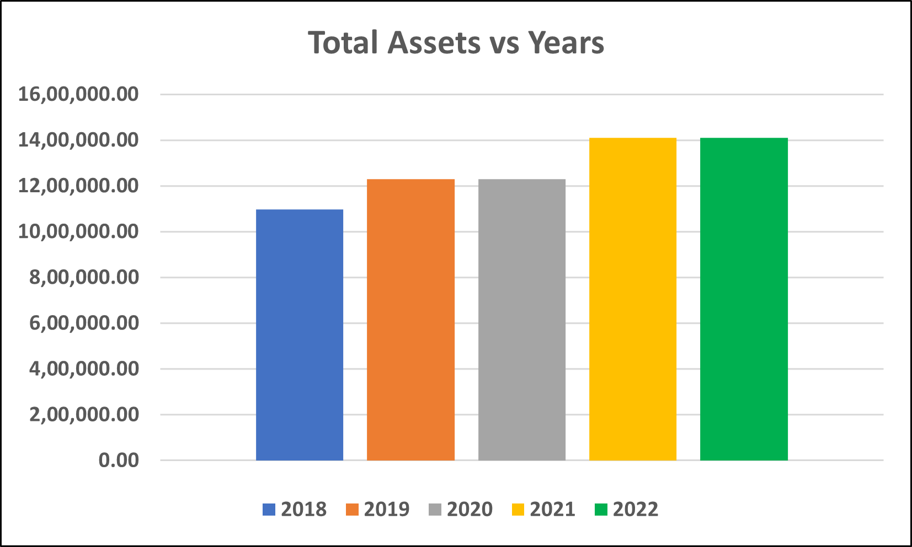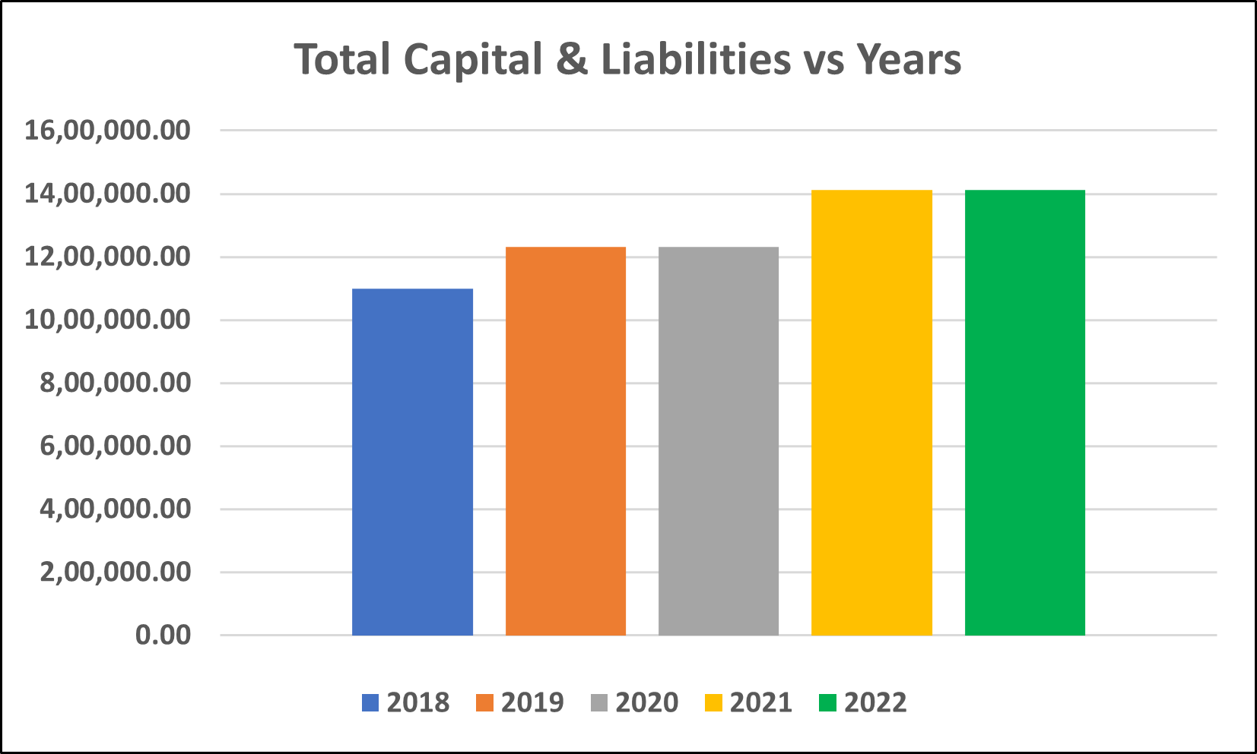

# PEER ANALYSIS

Based on recent news, we explored that there were crucial management changes in several Indian banks (both private and public) in the FY 2018-2019. Also, owing to the massive PNB scam in 2018, there was a loss of trust in the Indian Banking system, creating an overwhelming depreciation in value among several associatory banks within the banks that incurred the scams. Many banks are associated with one another through LoUs ( Letters of Undertaking ), from which it is possible that many banks were either directly or indirectly adversely affected. Likewise, speaking of ICICI Bank, it’s worth noting that, despite experiencing a negative broadcast owing to the management change in FY2019 ( October 2018 ), the firm has bounced back on the top securing **strong numbers** as previously reflected in the Key Financial Ratios Segment.

To judge the merit of the bank’s performance, we’ve executed an **additional test** by carrying out a **peer-to-peer analysis** of all Key Financial Ratios, against those banks that have been performing consistently with ICICI bank.

As of November 2022, we’ve gathered that ICICI bank is among the top 10 performing financial companies in India, and among all banks, it ranks 2nd behind HDFC Bank as per revenue. We’ve used market capitalisation as a metric to account for the peer group, the following are the banks used for Peer Analysis.

1. **HDFC Bank** ( *Private* ):- 897,529.79 ₹ Crore
2. **ICICI Bank** ( *Private* ):- 623,989.53 ₹ Crore
3. **State Bank of India** ( *Public* ):- 534,181.95 ₹ Crore
4. **Kotak Mahindra Bank** ( *Private* ): 381,049.06 ₹ Crore
5. **Axis Bank** ( *Private* ):- 260,935.91 ₹ Crore

|  |  |
| --- | --- |
|  |  |
|  |  |
|  |  |
|  |  |
|  |  |

From the above graphs, it can be clearly gathered that despite ICICI not depicting a clear dominance in any of the ratio determinants, it has consistently maintained a consistent profile against all its peers.

# FROM NOTES TO ACCOUNTS

## ACCOUNTING POLICIES:

**1) Revenue Recognition**

Interest income is recognised in the profit and loss account as it accrues. Dividend income is accounted on accrual basis.

**2) Investments**

Costs, including brokerage and commission pertaining to investments paid at the time of acquisition and broken period interest on debt instruments, are charged to the profit and loss account. Gain/loss on sale of investments is recognised in the profit and loss Account.

**3) Fixed Assets**

Fixed assets, other than premises, are carried at cost less accumulated depreciation. Premises are carried at revalued amount, being fair value at the date of revaluation less accumulated depreciation. Cost includes freight, duties, taxes and incidental expenses related to the acquisition and installation of the asset. Depreciation is charged over the estimated useful life of fixed assets on a straight-line basis.

**4) Translation of foreign currency items**

Foreign currency income and expenditure items of domestic operations are converted at the exchange rates prevailing on the date of the transaction. Expenditure items and income of integral overseas operations (representative offices) are converted at daily closing rates, and expenditure items and income of non-integral overseas operations (foreign branches and offshore banking units) are converted at quarterly average closing rates.

**5) Employee Stock Option Scheme (ESOS)**

The Employees Stock Option Scheme (the Scheme) provides whole-time directors and Bank’s employees and its subsidiaries’ employees with the grant of options on the Bank’s equity shares. The options granted vest in a graded manner and may be exercised within a specified period/time.

**6) Employee Benefits**

* Gratuity

The Bank pays a defined benefit plan, also termed as a gratuity, to employees who retire or resign following a minimum prescribed period of continuous service and, as per the applicable rules in the respective countries in case of employees at overseas locations.

* Superannuation Fund and National Pension Scheme

The Bank has a defined contribution plan, also termed a superannuation fund which is administered by trustees and managed by insurance companies. The Bank contributes 15.0% of the total annual basic salary for certain employees to superannuation funds.

* Pension

The Bank provides pension and dearness relief on a monthly basis to eligible employees on their retirement based on the respective employee’s years of service with the Bank and applicable salary. The pension payments come from a plan in which the Bank makes contributions to a trust which administers the funds on its own account or through insurance companies.

* Provident Fund

The Bank is bound by law to maintain a provident fund, a defined benefit plan, as a part of retirement benefits to its employees. Each employee contributes a certain percentage of his or her basic salary, and the Bank contributes an equal amount for eligible employees.

* Compensated absences

The Bank provides for compensated absence based on actuarial valuation conducted by an independent actuary.

**7) Income Taxes**

Income tax expense is the composite amount of the Bank’s sustained current tax and deferred tax expense. The current tax expense and deferred tax expense are determined as per the provisions of the Income Tax Act, 1961 and as per Accounting Standard 22 - Accounting for Taxes on Income respectively.

**8) Impairment of Assets**

The Bank follows revaluation model of accounting for its premises and the recoverable amount of the revalued assets is considered to be close to its revalued amount. For assets other than premises, the Bank assesses at each balance sheet date whether there is any indication that an asset may be impaired. Impairment loss, if any, is provided in the profit and loss account.

**9) Provisions, contingent liabilities and contingent assets**

Provisions are determined based on management estimates of amounts required to settle the obligation at the balance sheet date, in addition to experience of similar transactions. In case the loss on contingency is indicated by the available information but the amount of loss cannot be estimated, a disclosure to this effect is made in the financial statements. In case neither provision nor disclosure is made in the financial statements. The Bank does not account for or disclose contingent assets, if any.

**10) Earnings per share (EPS)**

Earnings per share is calculated by dividing the net profit or loss after tax for the year by the weighted average number of equity shares outstanding for the year.

**11) Share issue expenses**

Share issue expenses are deducted from Share Premium Account in terms of Section 52 of the Companies Act, 2013.

**12) Lease transactions**

Lease transactions recognised as an expense in the profit and loss account over the lease term on straight line basis.

**13) Cash and cash equivalents**

Cash and cash equivalents include cash in hand, balances with RBI, balances with other banks and money at call and short notice.

## MANAGEMENT COMMENTARY AND DISCUSSION:

* In fiscal 2022, the ICICI Bank maintained a strategic focus on **profitable growth in business** within the guardrails of risk and compliance.
* Leveraging its branch network, digital channels, partnerships and presence across various ecosystems, the Bank aims to expand its customer base using a **360-degree customer centric approach**.
* The ICICI Bank aims to serve all financial requirements of customers and their ecosystems. Using a concept of ‘ICICI STACK for Corporates’, the Bank offers **customized solutions** to corporates and their network of employees, vendors, dealers and other parts of their ecosystems.
* The Bank incorporates a **micro market based approach** to create an efficient distribution and resource allocation strategy strengthening the branch network where required.
* The Bank focuses on **internal cross-functional collaboration and external partnerships** to provide solutions that meet the complete banking requirements of customers.
* The Bank is transforming itself from **Bank to Bank-Tech**, with a focus on creating an enterprise architecture framework across digital platforms, data and analytics, micro services based architecture and other emerging technologies.

# Latest news and Firm updates

* ICICI Bank’s profit after tax (PAT) rose to ₹7,558 crores in Q2 FY-23, reporting a growth of 37% year-on-year, led by strong loan growth of 23% year-on-year and 5% quarter-on-quarter.
* ICICI Bank hiked fixed deposit interest rates for the second time in October which will allow senior citizens to earn up to 6.95%.
* ICICI Bank stayed among the top five performers on the Sensex and Nifty 50, while it was the best performer in the banking space.
* ICICI Bank surpassed estimates with double-digit growth in profitability and interest income, with healthier margins and improved asset quality in Q2 FY-23.

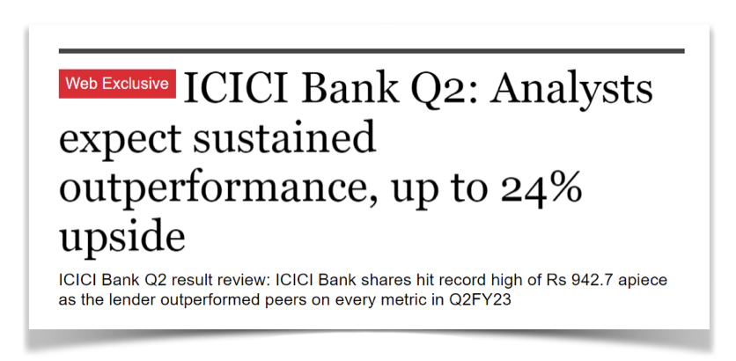

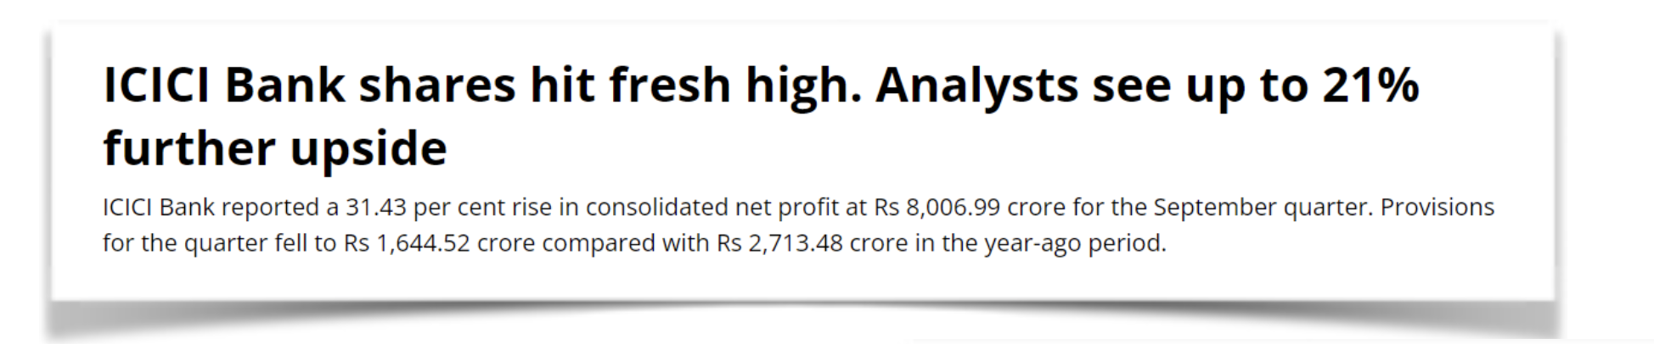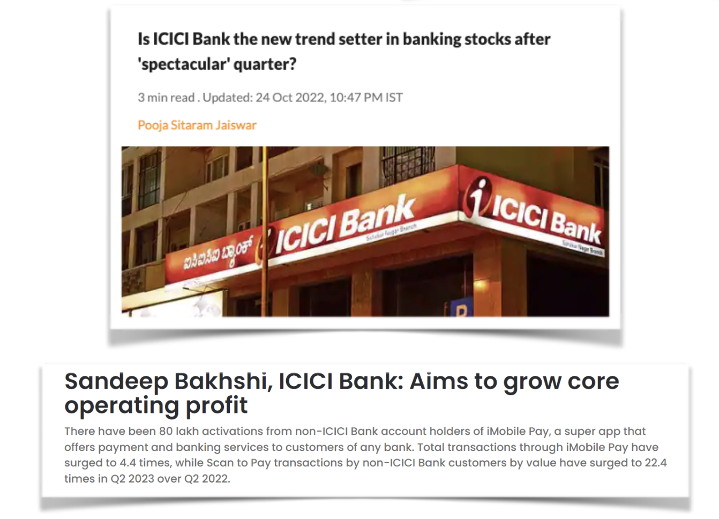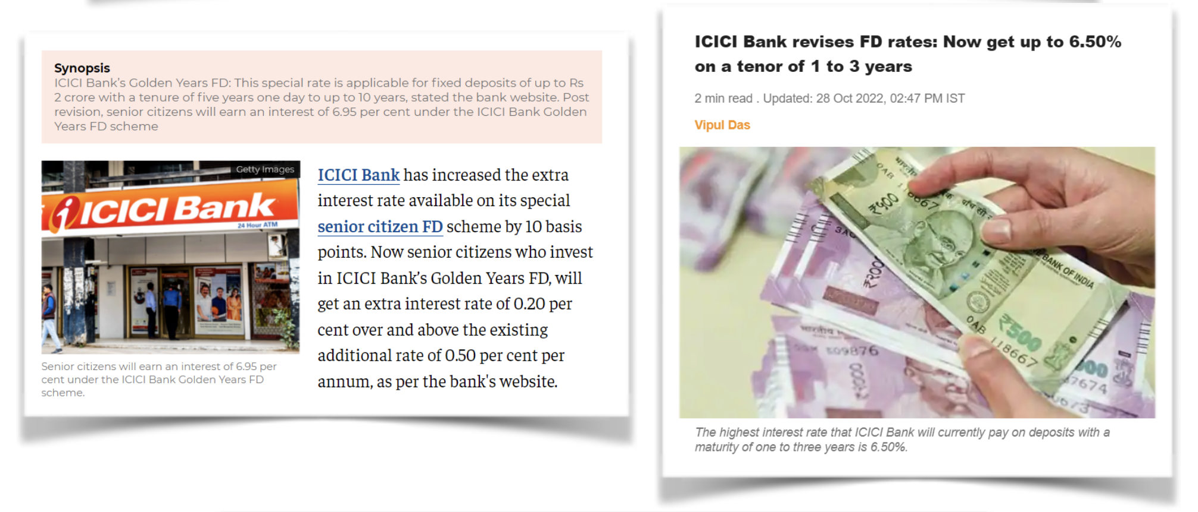

# 

# 

# 

# Annexures

**Investment Question:-**

Total Value of Investment till November 2022: **Rs.** 578719.5

Total Number of Shares till November 2022: 1104.0

Remainder Amount till November, 2022: **Rs.** 6255.5

**CODE (in PYTHON) FOR CALCULATION**:

| 1. **import** pandas as pd 2. df **=** pd.read_csv('sp.csv') 3. dividend_rate **=** dict() 4. dividend_rate['2018'] **=** 1.5 5. dividend_rate['2019'] **=** 1 6. dividend_rate['2020'] **=** 1 7. dividend_rate['2021'] **=** 2 8. dividend_rate['2022'] **=** 5 9. stock_prices **=** list(df['Close Price']) 10. months **=** list(df['Month']) 11. total_shares **=** 0 12. total_stock_value **=** 0 13. remainder **=** 0 14. **for** i **in** range(len(stock_prices)): 15. investment **=** 10000 **+** remainder 16. shares **=** investment**//**stock_prices[i] 17. total_shares **+=** shares 18. total_stock_value **+=** (shares**\***stock_prices[i]) 19. remainder **=** investment **-** (shares**\***stock_prices[i]) **+** total_shares**\***dividend_rate[months[i][**-**4:]] 20. print('Total Value of Investment till November, 2022: ', total_stock_value) 21. print('Total Number of Shares till November, 2022: ', total_shares) 22. print('Remainder Amount till November, 2022: ', remainder) |
| --- |

* Dividend Rate is taken from the moneycontrol website (link provided in the References Section).
* Stock prices are taken from the BSE website (link provided in the References Section) by downloading the CSV file (Rename it to ‘sp’).
* For stock prices, Close Price (Column) is being considered.
* Time period is taken from October 2018 to November 2022 (5 years).

# Bibliography

1. Balance Sheet, Income Statements and Cash Flow statements of the last 5 years
2. Annual reports from 2018 - 2022
3. Accounting policies and the Management Commentary of the firm.
4. Recent News Articles from Economics Times.

# References

* <https://www.fincash.com/l/brand/icici-bank>
* <https://www.icicibank.com/aboutus/bod-1.page?#toptitle>
* <https://www.business-standard.com/article/markets/icici-bank-q2-net-profit-may-rise-35-yoy-on-solid-loan-book-say-analysts-122102100145_1.html>
* <https://www.livemint.com/market/stock-market-news/is-icici-bank-the-new-trend-setter-in-banking-stocks-after-spectacular-quarter-11666629368216.html>
* <https://www.icicibank.com/aboutus/Annual-Reports/2021-22/AR/assets/pdf/icici-bank-ir-2022.pdf>
* <https://www.bseindia.com/markets/equity/EQReports/StockPrcHistori.aspx?expandable=7&scripcode=532174&flag=sp&Submit=G>